**COastal Landscape Transect Model (COLT) Model User’s Guide**

**1. Getting Started**

*1.1 Save program file to computer*

If you are running the COLT on a new machine, you must save the all of the program files under one folder. Copy the “COLT.zip” directly to your C drive, and unzip the contents of the file into a new folder, which will become the main directory of the model, where all model functions, plotting functions, inputs, and outputs are stored and name the folder “COLT”.

*1.2 Main file contents*

The following are the model functions which should be included in your COLT folder at the top level. These functions are required to run the model. Following the name of each function is a brief description of what each does:

Model Functions

biodepth Function to distribute belowground biomass with depth, as opposed to only the surface layer. Calculates exponential decay function to the depth of decomposition and then distributes the organic matter according to this function.

buildtransect Creates model domain and initial morphology of the bay, marsh,and upland slope. Marsh and bay depth are set to values close to equilibrium for the given sea level rise and suspended sediment concentrations.

calcFE Function to calculate the flux of organic matter (FE_org) and the flux of mineral sediment (FE_min) from the marsh to the bay,using the fetch for the current year (bfoc) the fetch for the previous year (bfop) and the stragtigraphy of organic and mineral deposition

decompose Decomposes all of the organic sediment within the marsh soil profile at a rate determined by depth.

evolvemarsh Calculates biomass and mineral and organic deposition, for each cell in the marsh as a function of flooding frequency. And calculates the total flux of sediment onto the marsh from the bay.

funBAY Determines change in bay depth and width by solving mass balance between fluxes of sediment into and out of the bay from marsh edge erosion, tidal exchange with the outside sediment source, and sediment deposited onto the marsh surface. From Mariotti and Carr (2014).

POOLstopp5 Necessary routine function to run ode solver for funBAY

transect Main function for the dynamic model for the morphological evolution of a backbarrier basin with marshes, mudflats, and an upland slope.

wavek Computes wave number via dispersion relationship

wavetau Calculates wave bed shear stress, as a function of fetch, wind speed, and bay depth. From Mariotti and Fagherazzi (2013)

waveTRNS Calculates wave power density at marsh boundary. From Mariotti and Carr (2014)

YeV Calculates wave height (Hs) and period (Tp) for a given fetch, wind speed, and depth; based on a set of semi-empirical equations Young and Verhagen (1996)

Plotting Functions

cfphase Creates phase diagrams of the results for a range of SSC and SLR for different upland slope values (recreate figure from Kirwan et al. 2016)

dMWvT Plots change in marsh width, as a function of edge erosion and forest retreat, through time for a given RSLR and Co

plotbaydepth Plots bay width and depth versus time

plotdeposition Function to plot the deposition of mineral and organic matter over the marsh surface for a given time step (ts) from a given model run (based on input parameters.

plotsurface Function to plot the surface profile for a given time step (ts) from a given model run (based on input parameters.

rgb Gives colormaps for plotting, written by Kristján Jónasson

Calibrate init conditions folder

calcDBequil Function to find the initial condition for bay depth at which the model will experience the lowest rate of change. Outputs an array of bay depths for a given combination of rate of sea level rise and external sediment supply. Will produce a different array for each fetch and wind speed conditions.

calcDMequil Function to find the initial condition for marsh depth at which the model will experience the lowest rate of change. Outputs an array of marsh depths for a given combination of rate of sea level rise and external sediment supply. Will produce a different array for each fetch and wind speed conditions.

Equilibrium Bay Depth.mat This matrix file contains the equilibrium bay depths for a range of SSC and RSLR values, for a given bay fetch.

Equilibrium Marsh Depth.mat This matrix file contains the equilibrium marsh depths for a range of SSC and RSLR values, for a given bay fetch.

funMARSH A 3-point dynamic model for the moprhological evolution of a backbarrier basin with marshes and mudflats – written by Giulio Mariotti

wetland3p Morphodynamic model that solves for changes in bay depth, used to determine equilibrium bay depth for a given set of conditions.

Run Files

This folder contains the run files where model inputs and outputs will be stored. It includes an example run file folder. Each run file will include an “Outputs” folder with all of the outputs variables and plots from the model run, and an “Input variables” where all of the input variables to be used for running the model are entered.

SpinUp Folder

buildstrat Function to take outputs from 1000yr model spinup and build a stratigraphy to use for all model runs

evolvemarsh Calculates biomass and mineral and organic deposition, for each cell in the marsh as a function of flooding frequency. And calculates the total flux of sediment onto the marsh from the bay.

Spinup Function to simulate the formation of a 1000m wide marsh onto a gentle upland slope (m) under a given set of conditions for sea level rise (R) and suspended sediment concentration (C), to be used as the initial condition for model runs. Generates the initial conditions from which the model is run.

MarshStrat.mat Contains the initial conditions from which the model runs will start, Each unit has a “surface” (elev_25), a mass of mineral sediment “min_25”, and a mass of organic sediment, both allochthonous (orgAL_25) and autochthonous (orgAL_25).

**2. Setting up input files**

*2.1 Creating input variables spreadsheet*

Before running the model, you must first create a set of input variables for the model to run. In your Windows Explorer, navigate to “C:\COLT”, and then open the “Run Files” folder. Copy and paste an existing folder (ie- “Example”) and rename the new folder (ie- “TestRun”). This will be your run folder, where all of your input variables and outputs from your model run will be stored. Open up your run folder, and then open up the excel spreadsheet “Input variables”. Here you’ll see a list of input variables that look like this:



The first row gives the description of the input variables, and the second row is where you type in your input variables, in the units prescribed in the top row. Save and close the spreadsheet before running the model. Do not rename the spreadsheet.

*2.2 Adding input variables for a range of conditions*

If you wish to run your model for a range of input conditions, you can add those to the rows below to create subsequent runs (See picture below). Each row of input parameters represents one run for the given set of conditions. Each of these runs will generate its own Outputs folder, saved under a name reflecting the inputs parameters chosen. (ie- “Outputs_RSLR3_CO20_Slope005”). Each row will then be assigned a “run index” that you’ll input when you go to run the model, to indicate which row of input variables you would like the model to execute.

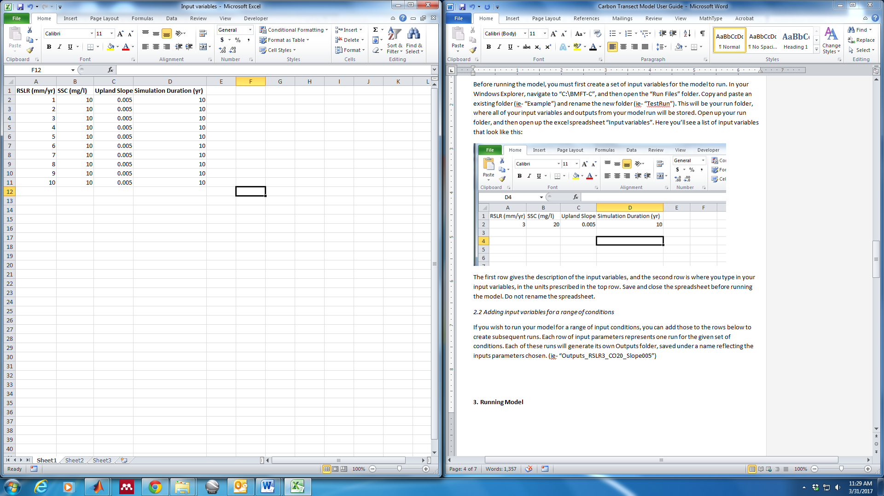

**3. Running Model**

*3.1 Open MATLAB and Navigate to Directory*

Before you can run the model, you must set the directory. From this directory, you can run the model, as well as any of the plotting functions.

Once you launch MATLAB, set your directory to the main directory folder for the model by selecting “Browse for Folder” and navigating to “C:\COLT”, or simply select “C:\COLT” from the dropdown box of recently used directories.

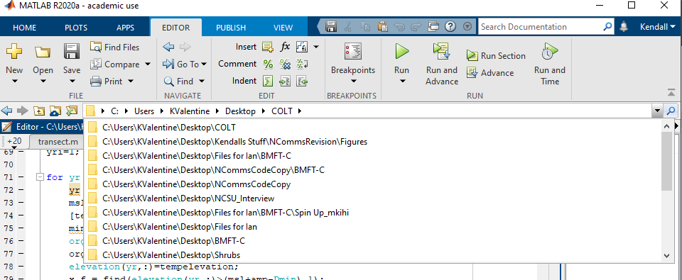

*2.2 Running model*

To run the model, type the following into the MATLAB command line, replacing RunFileName with your actual run file name:

transect(‘RunFileName’)

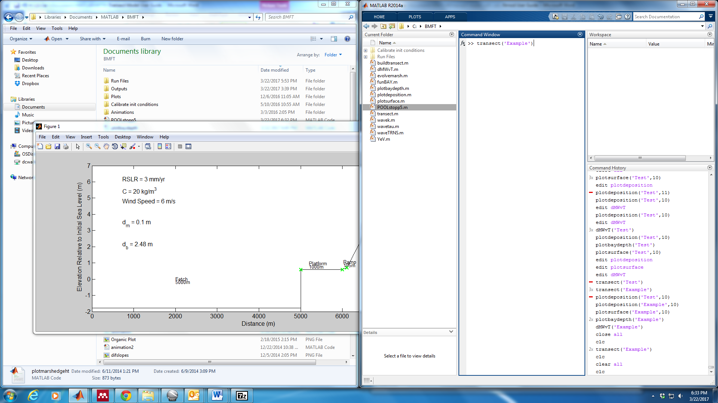

The model will run for the prescribed number of years using the input variables inputted on the first row of your Input variables spreadsheet, and will automatically save the output variables to the “Outputs” folder in your specified run file, reflecting the inputs parameters chosen. (ie- “Outputs_RSLR3_CO20_Slope005”).

If you wish to run the model for a range of conditions specified in your Input variables file, you must execute a “for loop” set up to loop through each of your runs. For instance, if you have 10 different rows of input variables that you would like to simulate, you would type:

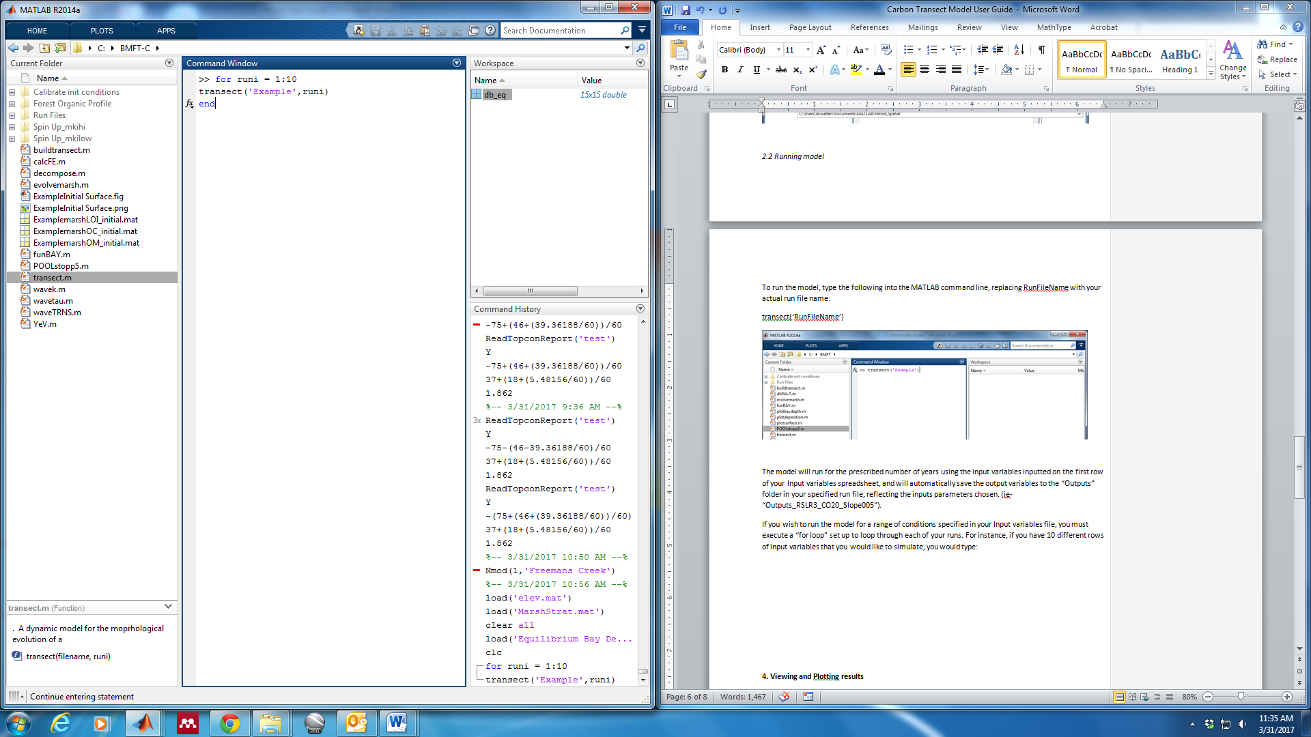

**4. List of Variables**

*4.1 Variables used in the text of the manuscript:*

Model parameters. The data sources for all parameters developed for this model are listed in the column named as Source.

|  |  |  |  |  |
| --- | --- | --- | --- | --- |
| **Symbol** | **Parameter** | **Value** | **Units** | **Source** |
|  | Lateral erodibility coefficient | 0.16 | m s-1 (W m-1)-1 | Mariotti and Carr 2014 |
| γ | Water specific weight | 9800 | N m-3 | Mariotti and Carr 2014 |
|  | Settling velocity – marsh | 0.05 | mm s-1 | Mudd et al. 2009 |
|  | Settling velocity – bay | 0.5 | mm s-1 | Mariotti and Carr 2014 |
| P | Tidal period | 12.5 | hours | Semidiurnal tide |
|  | Peak marsh biomass | 2500 | g m-2 | Morris et al. 2002 |
|  | Lateral progradation coefficient | 2 | dimensionless | Mariotti and Carr 2014 |
| Λ | Sediment decay coefficient | -0.0031 | m-1 | Kirwan et al. 2016 |
|  | Critical shear stress for erosion | 0.1 | Pa | Mariotti and Carr 2014 |
| Wind speed | Wind speed | 6 | m s-1 | Kirwan et al. 2016, Mariotti and Carr 2014 |
| Tidal amplitude | Tidal amplitude | 0.7 | m | Mesotidal |
|  | Mineral bulk density | 2000 | kg m-3 | Morris et al. 2016 |
|  | Organic matter bulk density | 85 | kg m-3 | Morris et al. 2016 |
| λ | Bay bottom erodibility coefficient | 0.001 | dimensionless | Mariotti and Carr 2014 |
|  | Minimum depth for marsh plant growth | 0 | m | Kirwan et al. 2016 |
|  | Maximum depth for marsh plant growth | 0.5204 | m | McKee and Patrick 1997 |
|  | Depth below which decomposition goes to zero | 0.4 | m | Rietl et al. 2021 |
|  | Coefficient of decomposition in the marsh | 0.1 | dimensionless | Rietl et al. 2021 |
|  | Forest biomass maximum | 5000 | g m-2 | Empirical, Fig. S1 (Chen and Kirwan, accepted in principle) |
|  | Tree biomass value at marsh-forest boundary | 1000 | g m-2 | Empirical, Fig. S1 (Chen and Kirwan, accepted in principle) |
|  | Tree growth rate | 2 | m-1 | Empirical, Fig. S1 (Chen and Kirwan, accepted in principle) |
|  | Background carbon accumulation in forest soils | 0.0001 | g m-2 | Empirical, Smith and Kirwan 2021 |
|  | Carbon layer from wetted soils | 5 | g m-2 | Empirical, Smith and Kirwan 2021 |
|  | Decay constant | 2 | m-1 | Empirical, Smith and Kirwan 2021 |
| *m* | Upland slope | 0.001 | dimensionless | Hussein 2009 |

*4.1 Variables used in code:*

amp Tidal amplitude (m) (is 2X tr)

B transect width (m)

Ba marsh progradation coefficient (--)

Be marsh erosion coefficient (m/yr/(W/m))

bfo initial bay fetch (m)

BMax g/m2 (I think this is maximum biomass)

C_e_ODE SSC at marsh edge (kg/m3) for each model iteration

Co Reference concentration (kg/m3)

Cr reference suspended sediment concentration in the bay (kg/m3)

Df average bay depth over tidal cycle (m)

Dist reference distance from marsh edge (m)

Dm marsh edge depth (m)

Dmax maximum depth below high water that marsh vegetation can grow (m)

Dmin minimum depth below high water that marsh vegetation can grow (m)

Dmo marsh edge depth (m)

Dur number of years to simulate (yr)

E Net flux of sediment eroded from the marsh edge (m2/s)

Fac proportion of tide that the bay is flooded (--)

Fc Net flux of sediment lost through tidal exchange with external sediment supply (m2/s)

Fc_ODE Mass flux of Fc for each iteration (kg/s)

Fetch fetch (m)

Fm_min Mass flux of mineral sediment to the marsh from the bay

Fm_org Mass flux of organic sediment to the marsh from the bay

Fp_sum amount of sediment taken from ponds to recharge sedimentation to drowning interior marsh

Lamda mudflat erodibility coefficient (--)

Mki decomp coefficient

Msl Mean sea level (m)

Mui depth in marsh where decomp goes to 0 (m)

Mwo initial marsh width (m)

OCb organic content of uppermost layer of bay sediment (determines OC of SSC), %

P Tidal period (s)

Rhob bulk density of the bay bottom (initially all mineral) (kg/m3)

Rhom bulk density of the marsh edge (kg/m3)

rhoo organic matter bulk density (kg/m3)

rhos sediment bulk density (kg/m3)

RSLR relative sea level rise rat (m/s)

Slope upland slope

SLR Sea level rise for a given year (m/yr)

Tau excess shear stress (Pa)

Tcr critical shear stress (Pa)

Tr Tidal range (m)

Tw wave bed shear stress (Pa)

W wave power density at the marsh boundary (W)

Wind reference wind speed (m/s)

Ws Settling velocity (m/s)

Wsf Settling velocity on mudflat (m/s)

Values for Constants

rhos 2000

rob 2000

rhoo 85

P 12.5*3600*1

Ws 0.05 x 10-3

Wsf 0.5 x 10-3

Tcr 0.1

Wind 6

Amp 1.4/2

Ba 2

Be 0.16/(365*24*3600)

Lamda 0.0001

Dist 10

Bfo 5000